Recipes Walk Through

Create a user test. Auto logged In

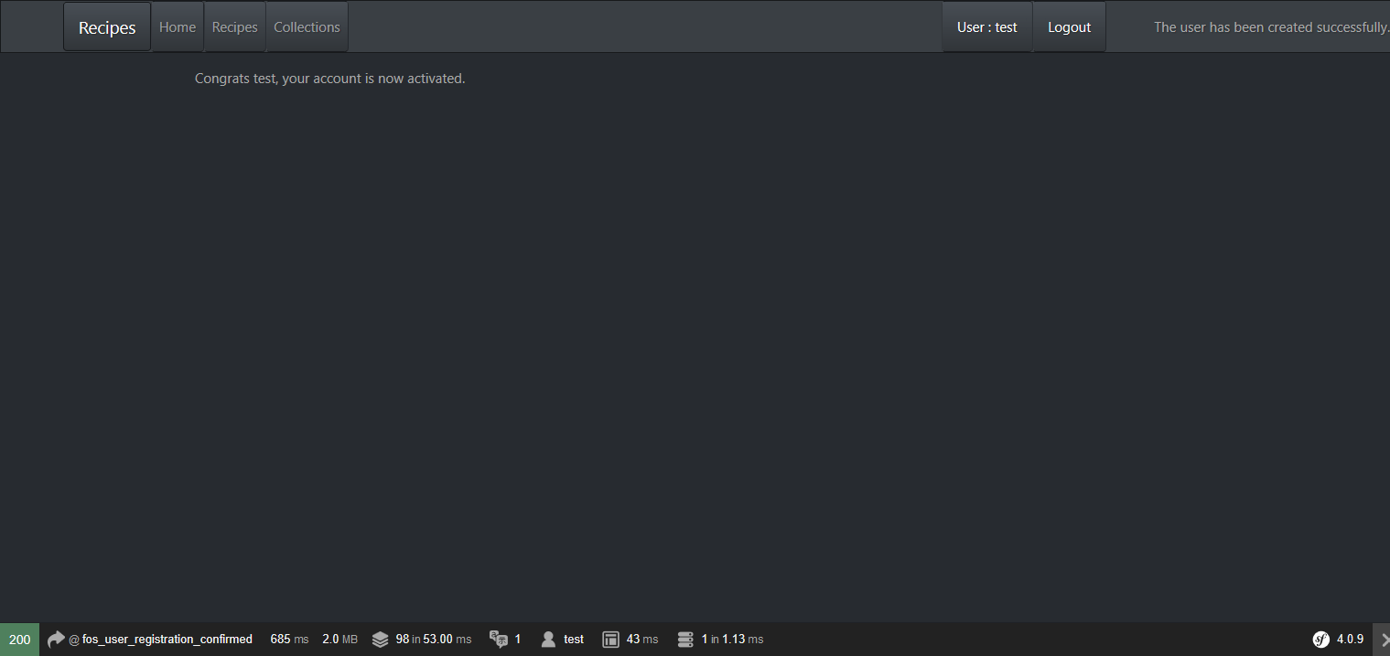

No recipes added, none visible

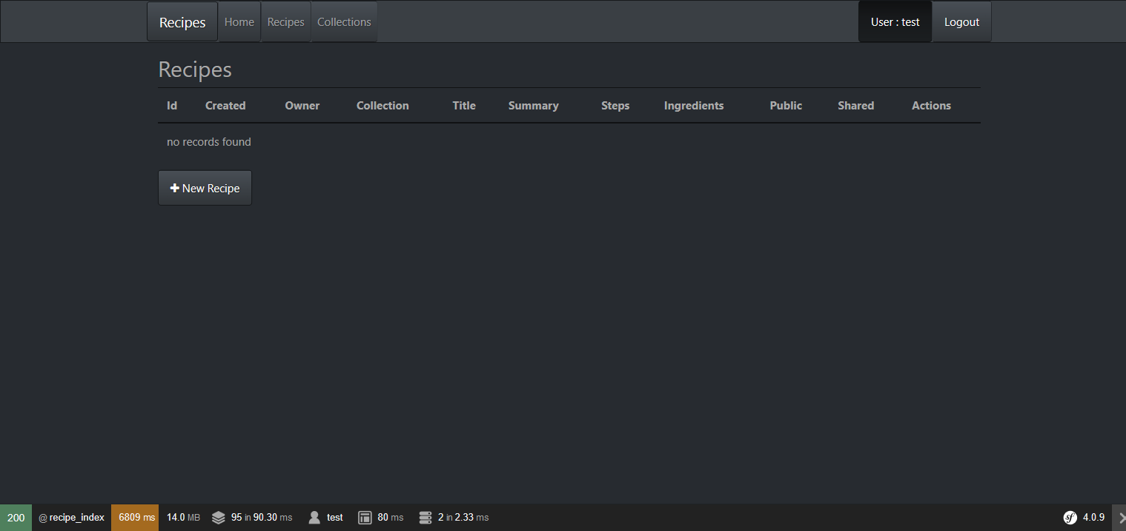

Add a recipe.

Note no collections added so can’t select one.

Add the steps and ingredients into a Memo field...one per line.

The recipe can be marked as shared or public at this point.

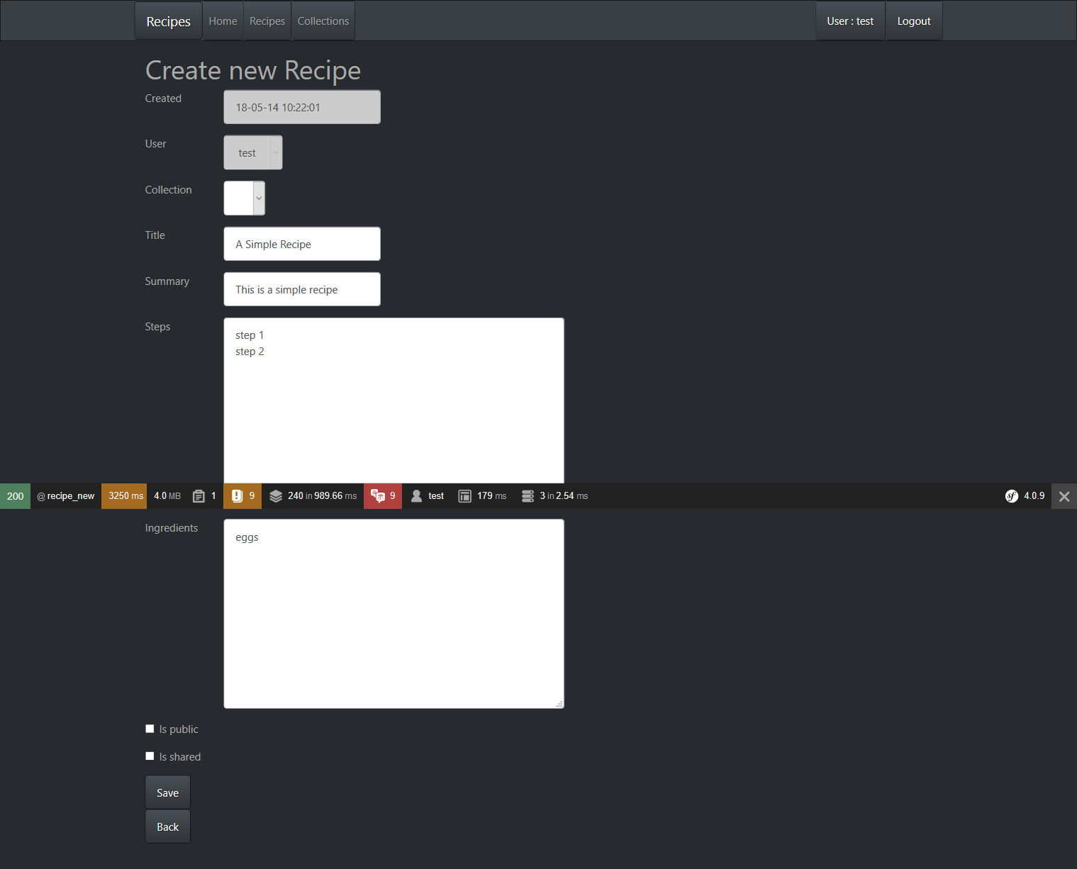

Recipes Table/Index View

Note owned by user test, the public and shared fields are buttons which toggle the state.

Once a recipe is public the button is disabled

There are action buttons to View, Edit, Share and Delete each Recipe – because they are owned by user test who is the current user.

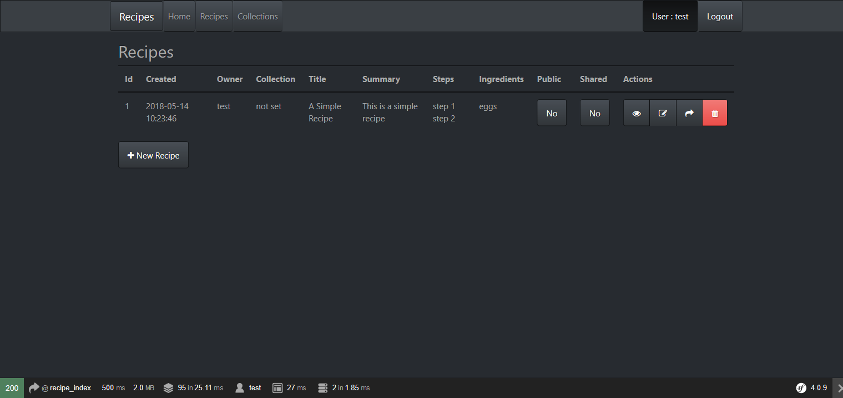

Add a new Collection

Note Collections like recipes can be Shared/Unshared or made Public.

Any Recipes in the Collection also become Shared/Unshared or Public

You can Recipes to the collection by clicking on the New Recipe button.

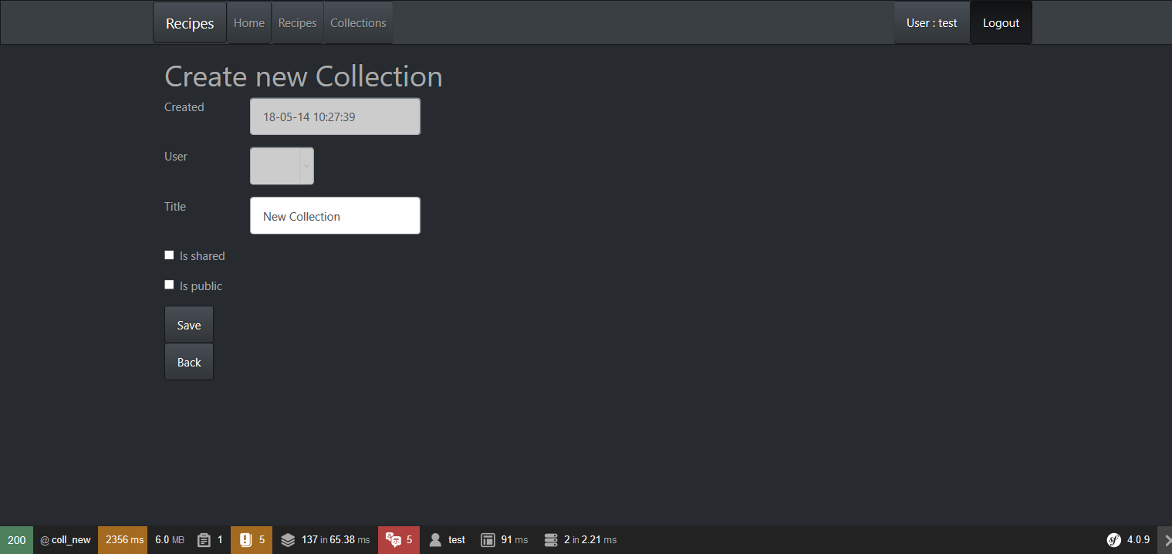

Note Recipes can be Shared or made Public independently of their Collection.

The Collection is Shared, so each Recipe is Shared.

The Collection is Private, but the Recipe has been made Public.

The Edit/Delete/Share buttons are active because user test is the owner

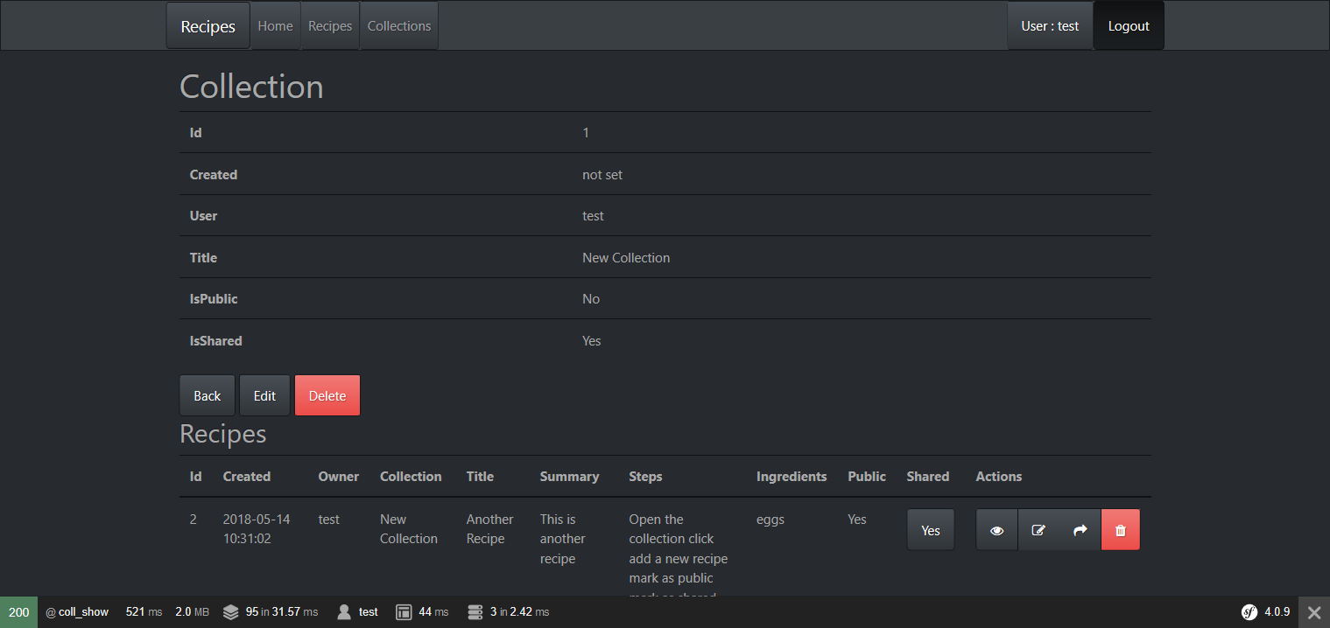

You can add comments to Recipes if you are logged in, and the recipe is visible (Public/Shared)

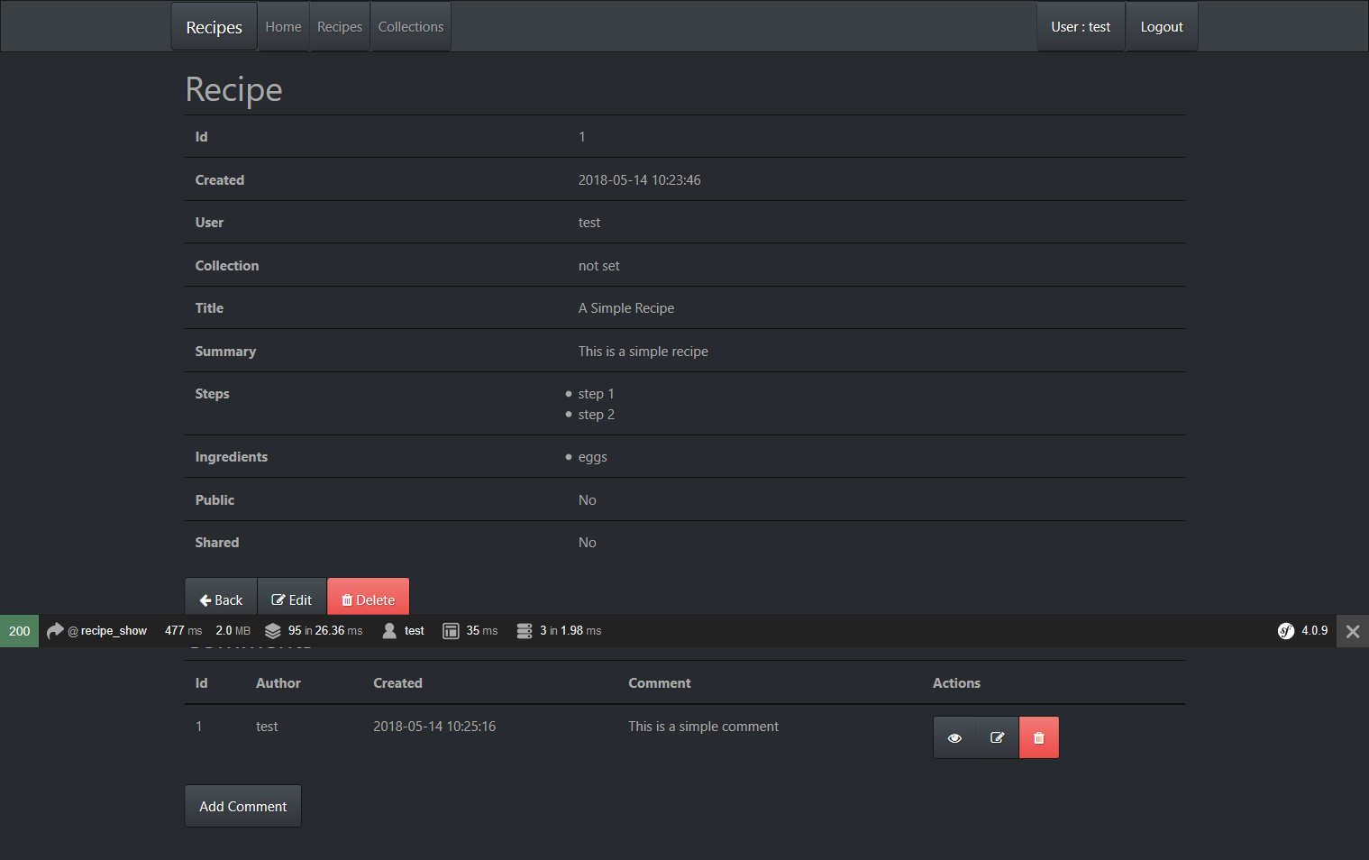

Log out and visit as anonymous user

Note only one recipe visible, because it is public.

Note Edit/Share/Delete action buttons have disappeared, because user not owner.

Note add button has disappeared because not logged in

Note the recipe has been added to a collection.

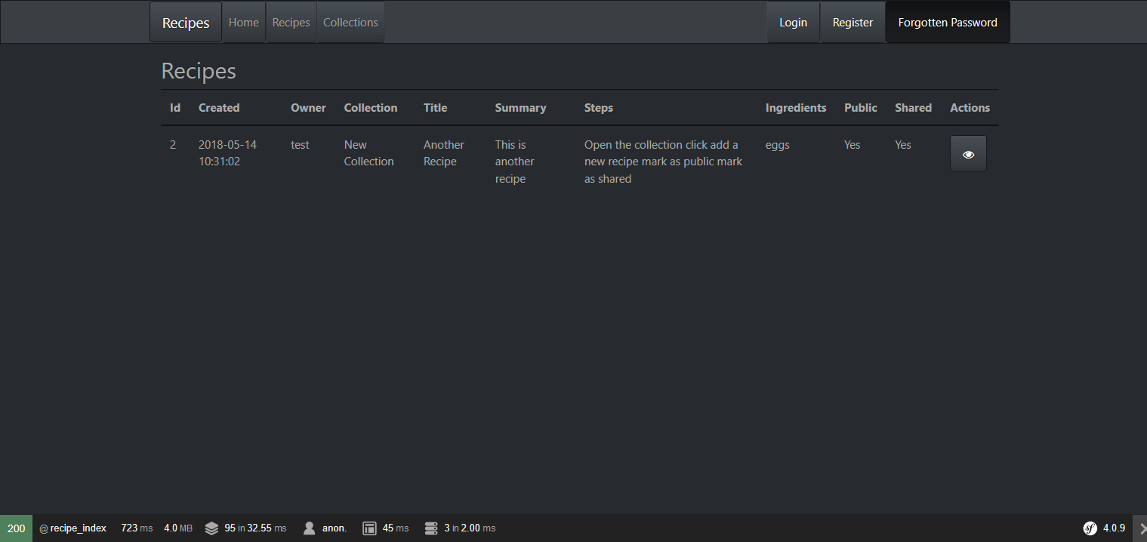

Register a new user test2

Note the validation check on the email...must be unique

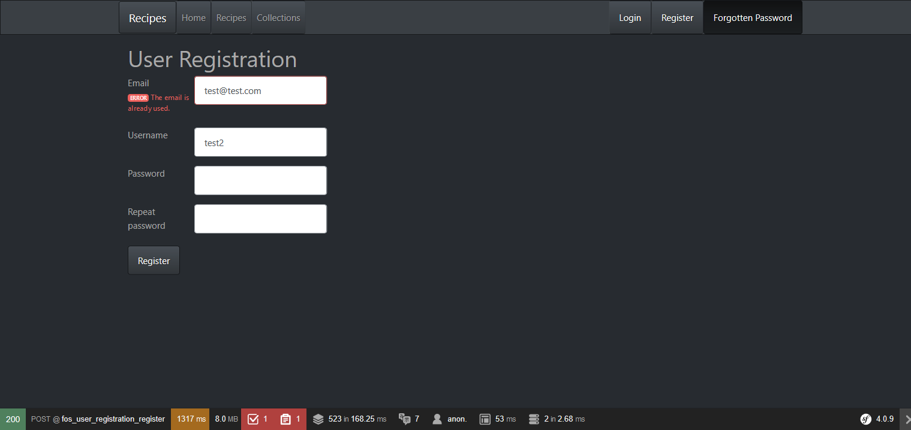

View Collections as user Test2

Note that the Collection is visible because it is shared, but not editable because it is not owned by user test2

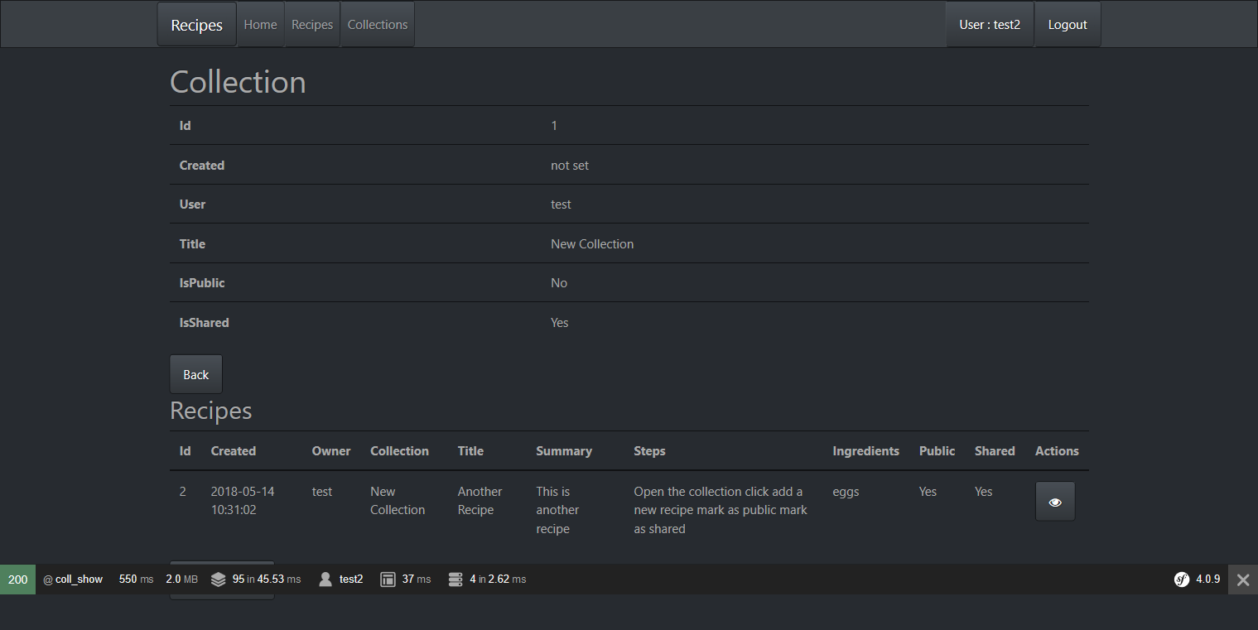

View Recipes as user Test2

Note two recipes are visible to user Test2 : one because it is public, the other because it is shared

Note the edit action buttons have been hidden because the recipes are owned by user Test

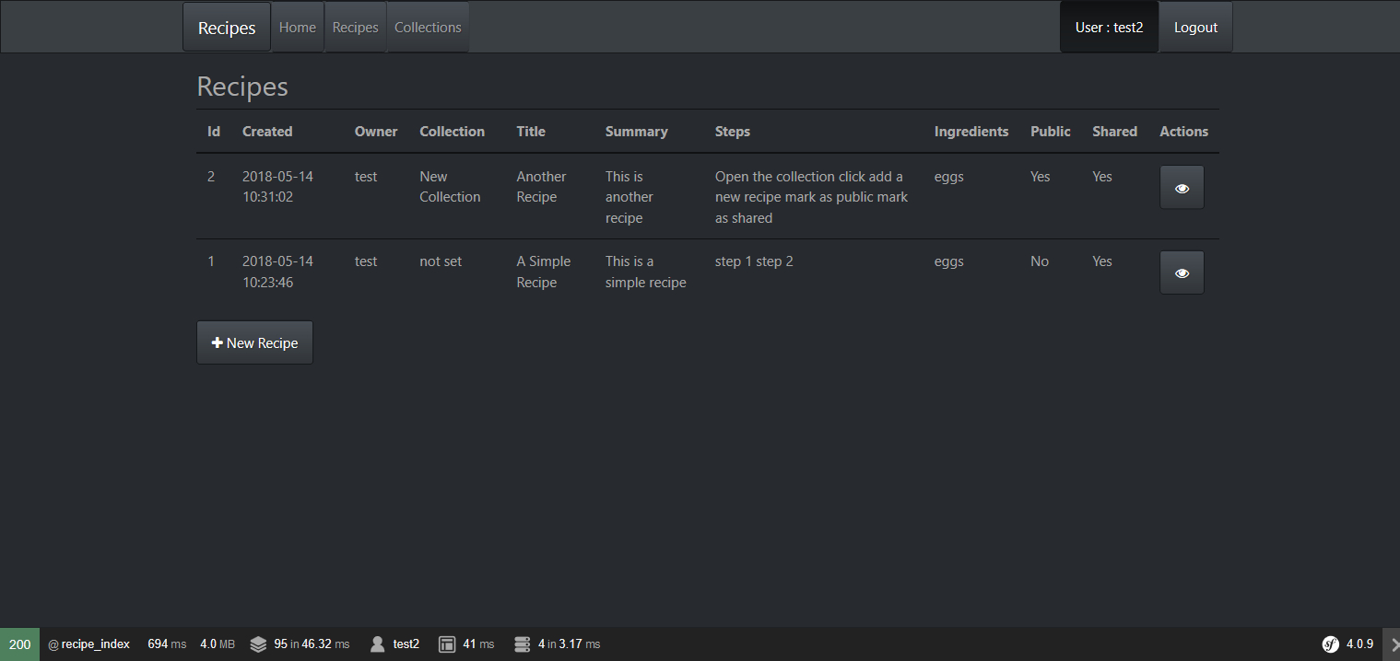

View the shared recipe

Note the edit/delete buttons are hidden

Note test2 can add a comment, and can edit/delete their own comment, but not the previous comment by user Test

